Summary List: Postpartum Thyroiditis (산후갑상선염)
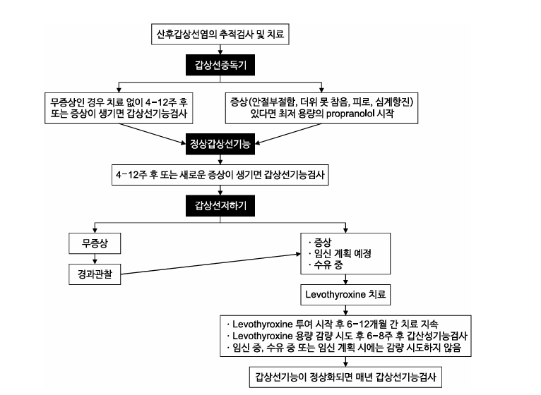
1. Definition and Clinical Significance
• Occurs within 1 year postpartum in women with previously normal thyroid function (excluding Graves' disease).
• Typical clinical course: Transient hyperthyroidism → Transient hypothyroidism → Recovery to normal thyroid function.
• Clinical variability:
○ 25%: Typical hyperthyroidism → hypothyroidism → recovery course.
○ 25%: Only hyperthyroidism.
○ 50%: Only hypothyroidism.
• Outcomes: 10-20% develop permanent hypothyroidism.
2. Causes of Postpartum Thyroiditis
• Autoimmune disorder associated with:
○ Thyroid autoantibodies (TAb, TPOAb)
○ Lymphocyte abnormalities
○ Increased natural killer (NK) cell activity
○ Specific HLA haplotypes
• High Risk: TPOAb+ women (33-50% develop postpartum thyroiditis)
• Occurs due to immune rebound after pregnancy-related immune suppression.
3. Differentiating Postpartum Thyroiditis from Graves' Disease
• Timing:
○ Postpartum thyroiditis: 1–6 months postpartum (peak ~3 months), lasting 1–2 months.
○ Graves’ disease: Typically after 6.5 months postpartum.
• Diagnostic markers:
○ TRAb: Positive in Graves', Negative in postpartum thyroiditis.
○ T4:T3 ratio: Higher in postpartum thyroiditis.
○ Radioiodine uptake: Increased in Graves’, decreased in postpartum thyroiditis.
• Breastfeeding women: Use 123I or 99mTc thyroid scans if necessary (short half-life); avoid 131I scans.
4. Prevalence and Risk Factors
• Prevalence: ~5% (range: 1.1%–16.7%).
• Increased risk with autoimmune diseases:
○ Type 1 diabetes: 3–4 times higher risk.
○ Chronic viral hepatitis: 25% risk.
○ Systemic lupus erythematosus (SLE): 14% risk.
○ History of Graves’ disease: 44% risk.
○ Pituitary autoantibodies: 27% risk.
• Recurrence risk: 70% in subsequent pregnancies.
5. Symptoms
• Hyperthyroid phase: Often mild or asymptomatic. Possible symptoms include:
○ Anxiety, heat intolerance, palpitations, fatigue.
• Hypothyroid phase: More symptomatic with:
○ Cold intolerance, dry skin, fatigue, poor concentration, body aches.
6. Relationship with Postpartum Depression
• Mixed study results on the association with postpartum depression.
• TPOAb+ mothers: Increased risk of postpartum depression.
• Thyroid hormone supplementation (LT4): Not effective in preventing postpartum depression.
• Recommendation: Screen for thyroid dysfunction in all patients with postpartum depression.
7. Treatment of Hyperthyroid Phase
• Typically self-limited, caused by thyroid cell destruction, not overproduction.
• Antithyroid drugs (PTU, MMI): Not recommended.
• Symptomatic treatment:
○ Use lowest dose of beta-blockers (e.g., propranolol) if needed.
○ Beta-blockers are safe during breastfeeding.
8. Follow-up after Hyperthyroid Phase
• Monitor for hypothyroidism:
○ Check TSH 4–12 weeks after resolution of hyperthyroidism.
○ Perform TSH test if new symptoms arise.
9. Treatment of Hypothyroid Phase
• Indications for LT4 therapy:
○ Symptomatic hypothyroidism.
○ Breastfeeding women.
○ Women planning pregnancy.
• If LT4 not started:
○ Monitor thyroid function every 4–12 weeks until recovery.
○ Recommend contraception until thyroid function normalizes.
10. Duration of LT4 Treatment
• No established duration.
• If LT4 started:
○ Consider tapering or stopping at 12 months postpartum if not pregnant or breastfeeding.
○ Monitor TSH every 6–8 weeks during dose reduction.
○ Continue full dose during pregnancy or breastfeeding.
11. Long-Term Monitoring
• Risk of progression to permanent hypothyroidism: 10–50%.
• Risk factors:
○ Multiple pregnancies.
○ Thyroid ultrasound findings (hypoechogenicity).
○ Severe initial hypothyroidism.
○ High TPOAb titer.
○ Older maternal age.
○ History of miscarriage.
• Annual TSH measurement recommended for life.
12. Prevention of Postpartum Thyroiditis
• LT4 or iodine supplementation during pregnancy: Not effective in preventing postpartum thyroiditis.
• Selenium supplementation: Conflicting evidence.
○ Potential benefit in reducing TPOAb and permanent hypothyroidism.
○ No proven reduction in postpartum thyroiditis incidence.
○ Caution: Selenium may increase diabetes risk.
• Current guidelines:
○ Do not recommend LT4 or iodine for prevention.
○ Selenium supplementation: Not recommended due to insufficient evidence.

This structured summary provides a comprehensive, quick-reference guide to postpartum thyroiditis for clinical use.

출처: <https://chatgpt.com/c/67b1322b-db38-8010-8d84-934e6719cb48>

